CC01 - PRODUCT ORDER MANAGEMENT
Description
Instruction:
1.if you are using TLAB**, Sample compile and run JCL is available in "TLABADM.LAB.SYS.COMPRUN". Please go in view mode and copy the members to your deliverable dataset.
2. if you are using TLAB**,the IP address is 10.142.149.210 and the Port is 623 to connect to Mainframe Terminal
Please do not EVALUATE and just SUBMIT the code for Evaluation - CC/MOCK/ICT assessments.

Objective:
To create a COBOL-VSAM application to PRODUCT ORDER MANAGEMENT.
- Allocate the below PDS with the following parameters given below

2. INPUT LAYOUT
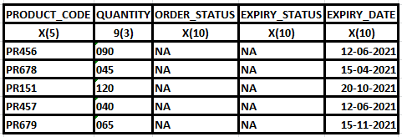

3. OUTPUT LAYOUT
4. Write a COBOL program to achieve the below requirement.
I. If the expiry date of the product is on or before current date, then set the expiry status as 'EXPIRED', priority as 'NA' and orders status as 'RETURN'
II. If the expiry date of the product is after the current date, then set the expiry status as 'NOTEXPIRED', orders status as 'ORDER' and update the priority as mentioned below
a. If the quantity of the product is greater or equal to 075 , then update the priority to 'HIGH'
b. If the quantity of the product is less 075 , then update the priority to 'LOW'
III. Write the updated records in the output file.
5. Use the below DD names for the input and output files.
DDNAME : INPRDS - USERID.MYDATA.CC01.PS1
DDNAME : OUTPRDS - USERID.MYDATA.CC01.PS2

INSTRUCTIONS:
- Follow the proper coding standards
- Provide proper error handling routines.

EXPECTED DELIVERABLES
- COBOL PROGRAM
- RUN JCL

Evaluation Procedure:
1) Use your run JCL to compile the Program and test your program with the necessary inputs and make sure you get the return code MAXCC 00 before submitting it for Evaluation.
2) Download your dataset (USERID.MYLIB.CC01(CC01CB01) ) to your system and name the file CC01CB01.txt
3) Download your run JCL with the necessary inputs as per the QB Requirement and name it RUNJCL.txt
4) Drag the file into the code Editor.
5) Then Press the Evaluate button for Evaluation.

